Report On Local Place Recommendation

IBM

Himanshu Raj

Place Of Observation : Kolkata

In this capstone project we have decided Kolkata as our location main aim of our project is give an idea about the provided city. Here we can see the number of different venues in our store which can tell a lot about city like number of malls, resturants, parks , hospitals. Here is our data screenshot for more you can visit this provided link to know more about it there will be a dataset containing venue types along with it number.(Link : https://github.com/himanshuraj001/Coursera_Capstone/blob/master/kolkata_details/kolkata_disribution.csv)

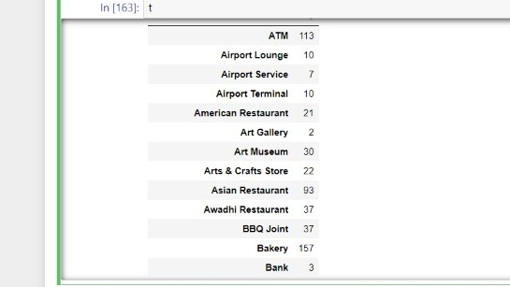

Example 1

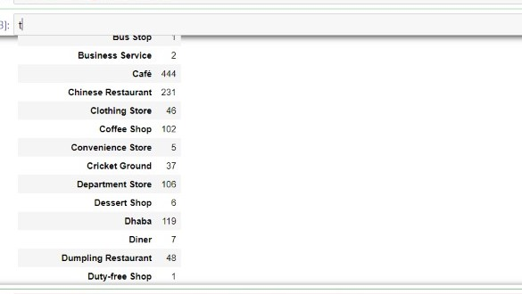

Example 2

As discussed in project document last week here we can also show what area is useful for what or what is distribution of various venue suppose anyone want to open school, malls, any café, restaurant or anyone is trying to find any locality with these features here we can solve both problems. Here we are taking shopping mall for an example. So we have extracted dataset which you can visit in our notebook or on our github. Here we are only shoeing screenshots.

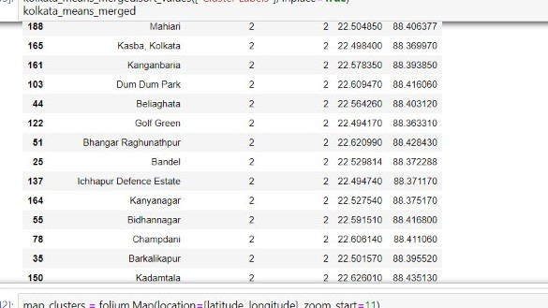

Here is the example of dataset that contains the name of locality along with number of shopping malls and its coordinates. So anyonecan chose locality according to its prespective with help of it.

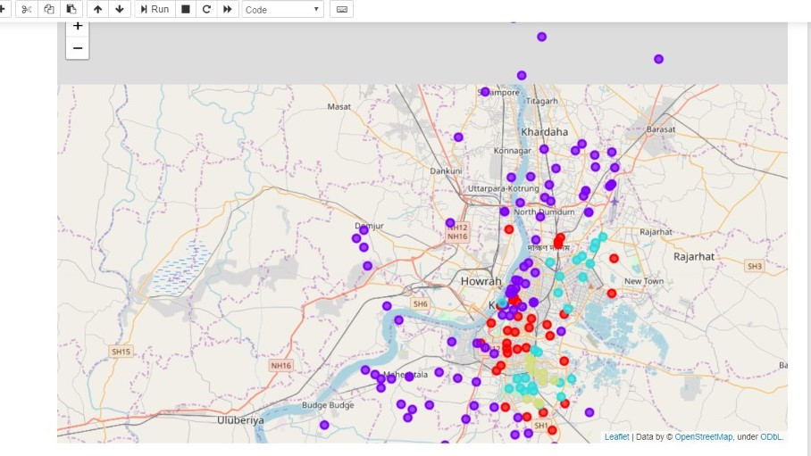

Here we are showing the overall distribution of malls in Kolkata.

We have also applied Kmeans on top visited places in locality and we get this as our cluster shown below it can also have a lot of interprations like places famous for and similar locality and if anyone wants to open a business what he can open that is most in demand and many more.

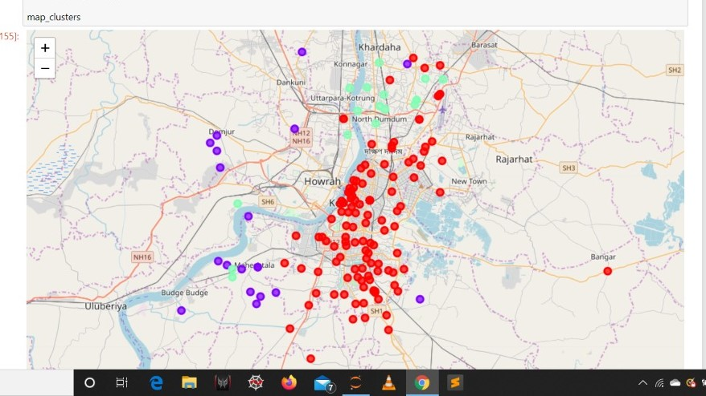

So it can have a lot of significance.